1

22

333

4444

55555

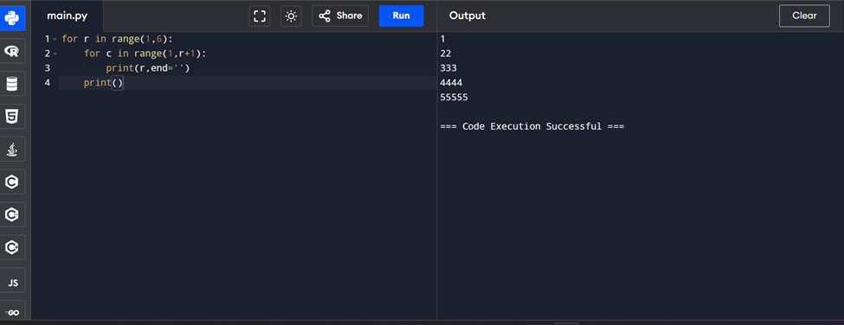

**Write a python program ask student details, then 5 sub marks, perform the total and calculate a percentage then give them a grade.**

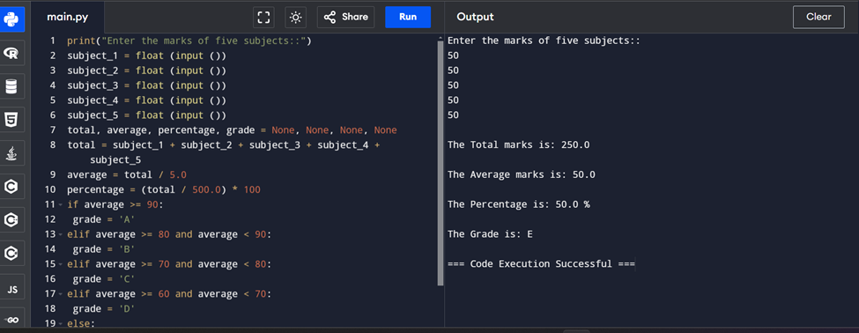

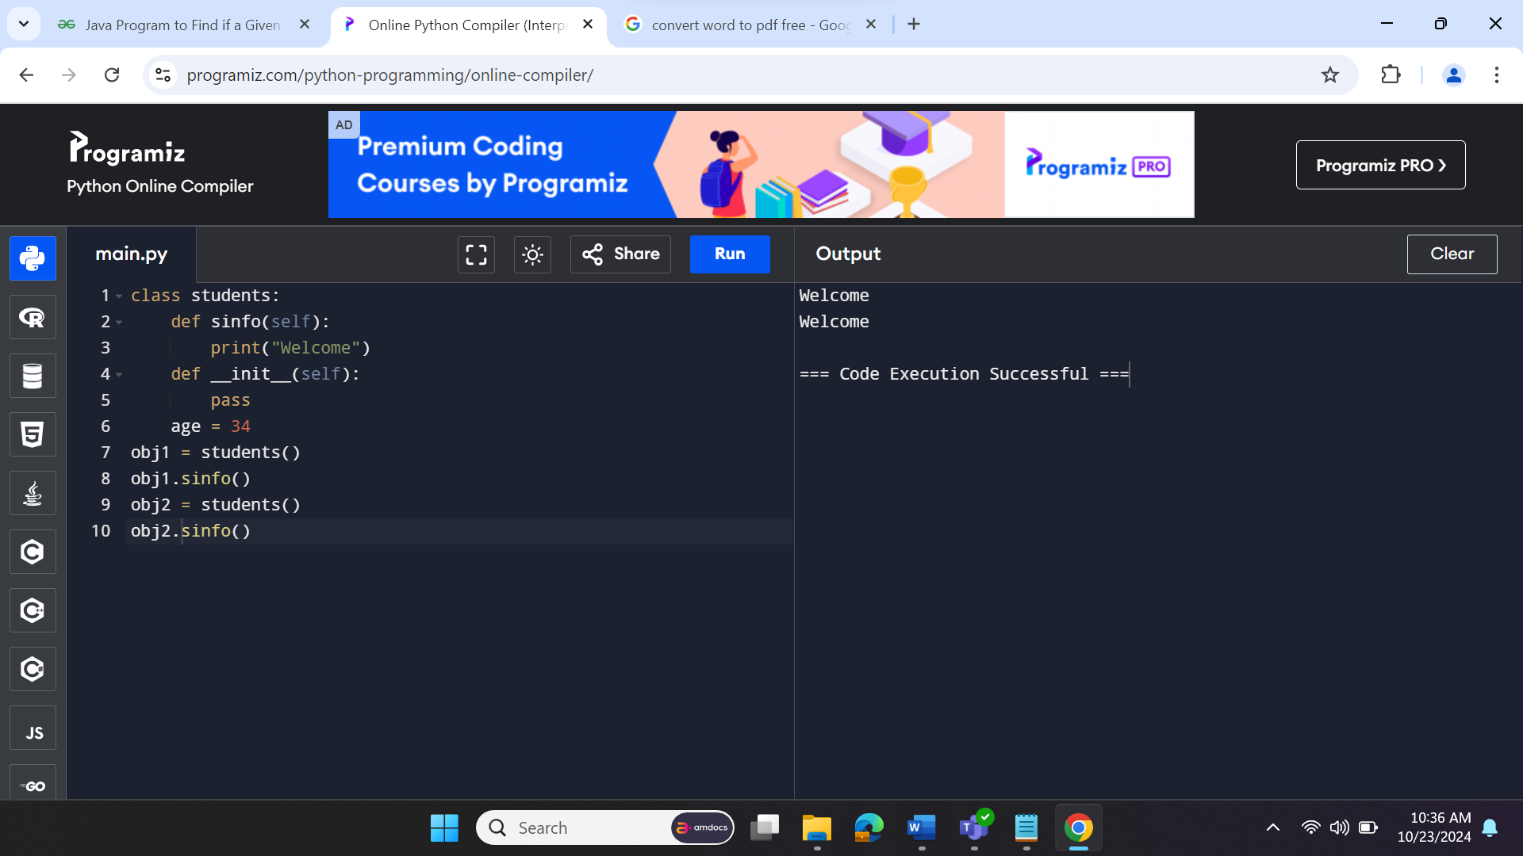

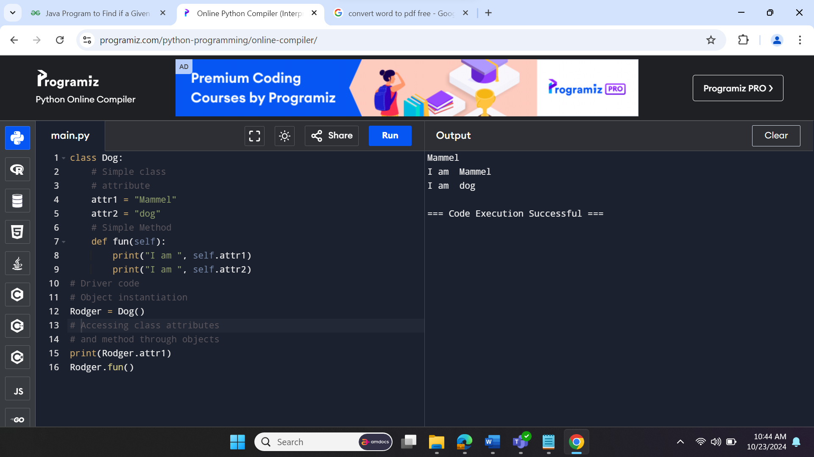

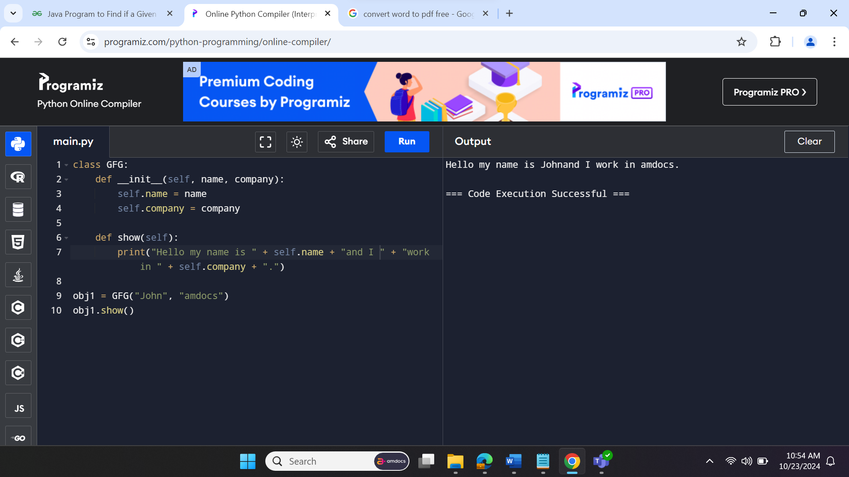

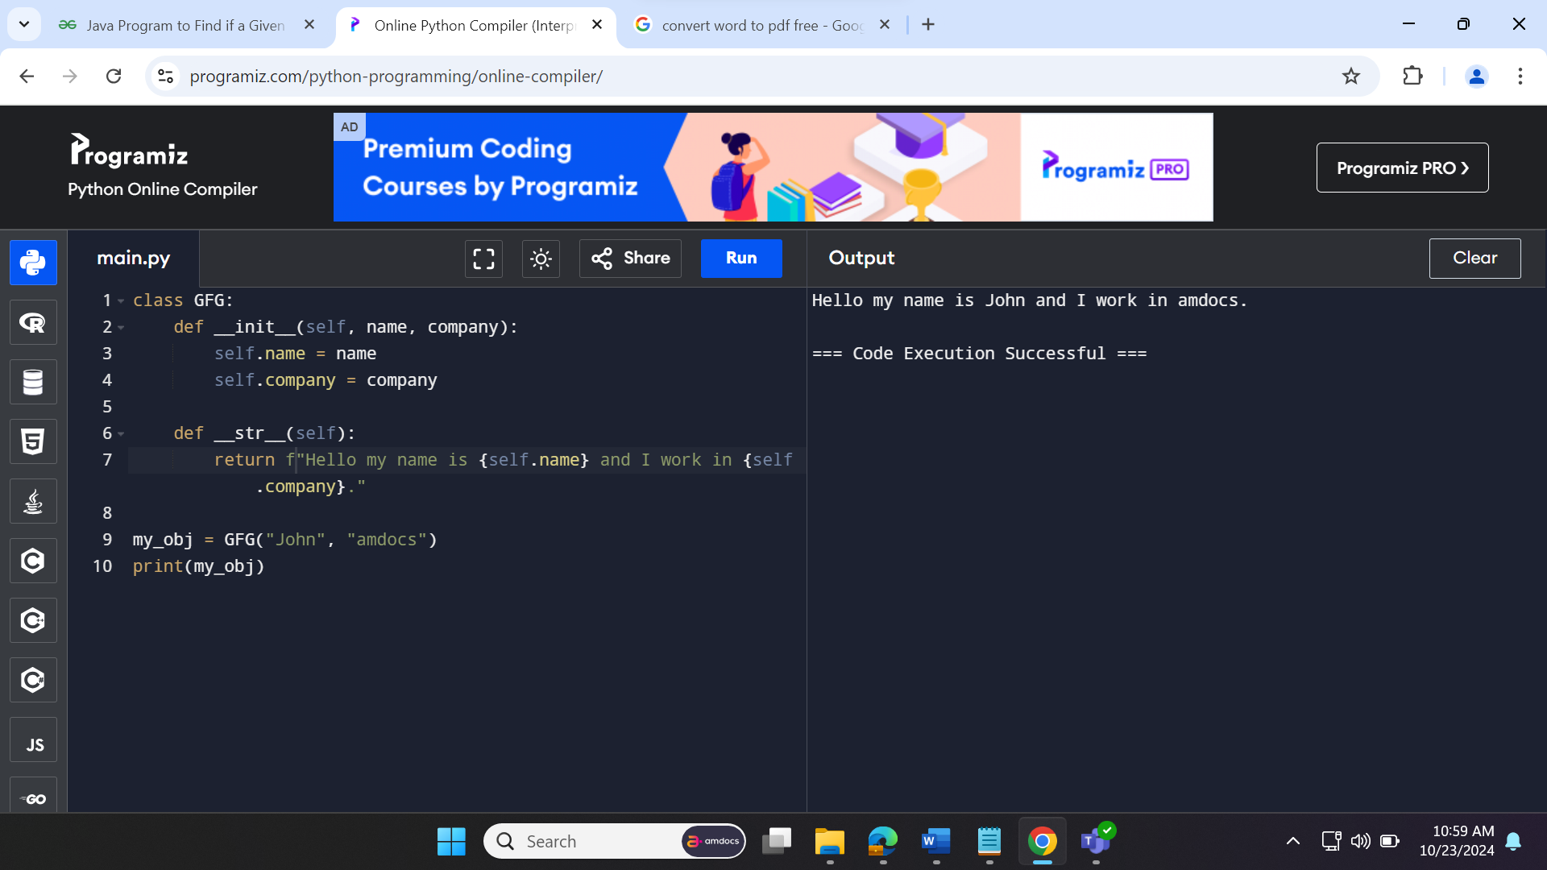**­**

| **OOP** | **POP** |
| --- | --- |
| [Object oriented](https://www.geeksforgeeks.org/introduction-of-object-oriented-programming/). | [Structure oriented](https://www.geeksforgeeks.org/difference-between-structured-programming-and-object-oriented-programming/). |
| Program is divided into objects. | Program is divided into functions. |
| Bottom-up approach. | Top-down approach. |
| Inheritance property is used. | Inheritance is not allowed. |
| It uses access specifier. | It doesn’t use access specifier. |
| Encapsulation is used to hide the data. | No data hiding. |
| Concept of virtual function. | No virtual function. |
| Object functions are linked through message passing. | Parts of program are linked through parameter passing. |
| Adding new data and functions is easy | Expanding new data and functions is not easy. |
| The existing code can be reused. | No code reusability. |
| use for solving big problems. | Not suitable for solving big problems. |
| [C++](https://www.geeksforgeeks.org/c-plus-plus/), [Java](https://www.geeksforgeeks.org/java/). | [C](https://www.geeksforgeeks.org/c-programming-language/), Pascal. |

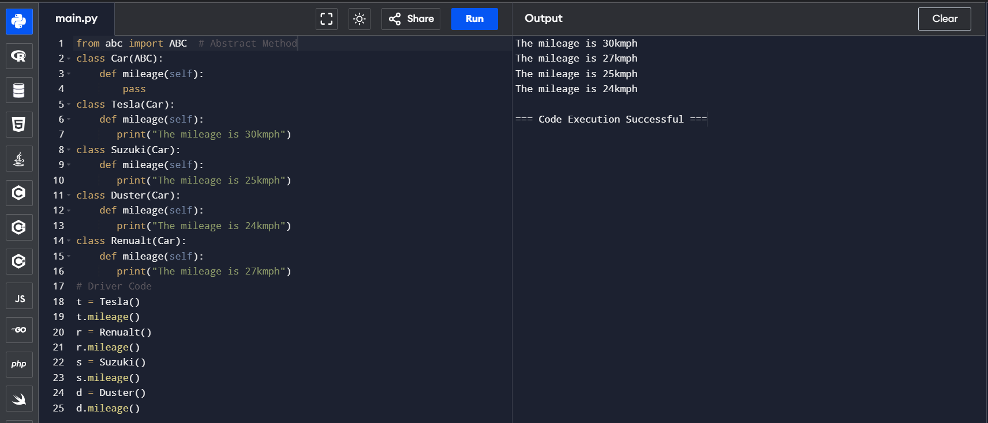

**What is abtraction ?**

Data abstraction in Python is a programming concept that hides complex implementation details while exposing only essential information and functionalities to users. In Python, we can achieve data abstraction by using abstract classes and abstract classes can be created using abc (abstract base class) module and abstractmethod of abc module.

**What is the need of Abstraction ?**

In Python, an abstraction is used to hide the irrelevant data/class in order to reduce the complexity. It also enhances the application efficiency. Next, we will learn how we can achieve abstraction using the [Python program](https://www.javatpoint.com/python-programs).

**Abstraction classes in Python**

In [Python](https://www.javatpoint.com/python-tutorial), abstraction can be achieved by using abstract classes and interfaces.

A class that consists of one or more abstract method is called the abstract class. Abstract methods do not contain their implementation. Abstract class can be inherited by the subclass and abstract method gets its definition in the subclass. Abstraction classes are meant to be the blueprint of the other class. An abstract class can be useful when we are designing large functions. An abstract class is also helpful to provide the standard interface for different implementations of components. Python provides the **abc** module to use the abstraction in the Python program. Let's see the following syntax.

